## API User Tutorial for Business Node

Before using this manual, you need access to one existing Business Node (BN), or you have set up your local BN via [Setup a Business Node(BN) with docker-compose](https://github.com/UDPN/BN-Sandbox-selfservice-public) (Please ensure to complete the onboarding process).

Please read UDPN white paper first to understand the high-level architecture of the UDPN better. The latest version of the UDPN white paper can be downloaded:

1. From UDPN official site soon (http://udpn.io)
2. Shared by your dedicated UDPN contact person.
3. Or from your sandbox instance if you have one: [https://*.sandbox.udpn.io](https://*.sandbox.udpn.io) -> Home -> “Download Whitepaper”

Please note that the details regarding the API parameters can be found via Swagger API:

1. From your local BN:

<http://localhost:8082/swg/swagger-ui/index.html?urls.primaryName=bnprocesscore>

1. From your UDPN sandbox, if you have access to one. Confirm with your dedicated UDPN contact:

[https://bngateway-yourDomainURL/swg/swagger-ui/index.html](https://your-public-sandbox-URL/swg/swagger-ui/index.html)

1. From a UDPN public BN instance (read-only, cannot trigger API call)

<https://bngateway-rd.sandbox.udpn.io/swg/swagger-ui/index.html>

Summary of API use for sending transfer or SWAP transactions on behalf of your end user:

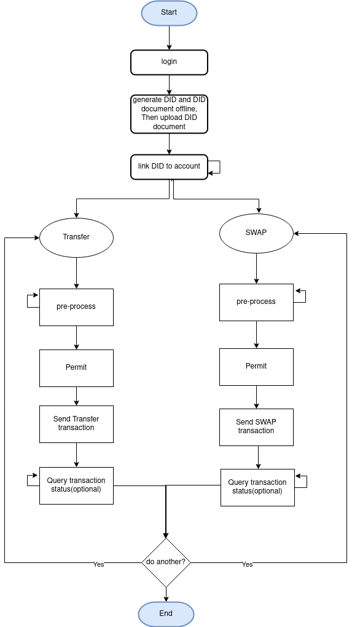

Please find below the core APIs used by the IT system operators to connect to business nodes. Additional details on the API can be found in the Swagger description provided above. All URLs come from setting up the BN locally via [Setup a Business Node(BN) with docker-compose](https://github.com/UDPN/BN-Sandbox-selfservice-public).

In addition to this tutorial, we will provide a PostMan project demonstrating how to use the API calls introduced below to complete a SWAP transaction.

Note: Again, All URLs in following chapters come from setting up the BN locally via [Setup a Business Node(BN) with docker-compose](https://github.com/UDPN/BN-Sandbox-selfservice-public).

### Login

The IT system uses this API to log in to their business node. The default username/password could be found at [this page](https://github.com/UDPN/BN-Sandbox-selfservice-public/blob/main/sandbox.manual.md) if you are using [Setup a Business Node(BN) with docker-compose](https://github.com/UDPN/BN-Sandbox-selfservice-public). More APIs could be found via swagger.

<http://localhost/v1/udpn/processing/login/manage/login>

### DID Document Uploading

A DID is a unique identifier used to represent all UDPN users. You may generate DID document with below ways:

1. From your sandbox instance if you have one: [https://*.sandbox.udpn.io](https://*.sandbox.udpn.io) -> “Account Management” -> “DID generation”
2. If you are using [Setup a Business Node(BN) with docker-compose](https://github.com/UDPN/BN-Sandbox-selfservice-public), you need to navigate to the root directory “BN-Sandbox-selfservice-public” and generate an offline DID document on behalf of the end-user using the following command

“java -jar docker-compose/nginx/dist/web/assets/did/udpn-did-sdk-1.0.0.jar”.

After the DID document is generated, you must use the command below to upload it to a validator node via your business node.

<http://localhost/vn/v1/udpn/did/manage/didContract/storeDidDocumentOnChain>

### Link DID to Account

The DID needs to be linked to a digital currency account before we can transfer/swap funds from that account on the UDPN.

<http://localhost/v1/udpn/processing/account/bind/manage/save>

1）Query all currencies and platforms currently supported on the UDPN.

<http://localhost/v1/udpn/processing/common/manage/active/currency/platform/select>

1. Query account list with accountBindingId .etc fields linked to specific DID

<http://localhost/v1​/udpn​/processing​/account​/bind​/manage​/searchs>

1. More details on the APIs can be found in swagger

### Transfer

“Transfer” means moving funds between two accounts in the same digital currency system.

##### Pre-processing

For a given transfer, query all possible TNs which could process the transfer.

<http://localhost/v1/udpn/processing/transfer/manage/searchs>

Related query: query all platforms and currencies currently supported on the UDPN.

<http://localhost/v1/udpn/processing/common/manage/active/currency/platform/select>

##### Permit

Once a transaction node is chosen to process the transfer, use this API to collect the relevalt public chain package details.

As a temporary fix, we pass the end-user private key to the transaction node so that it signs the transaction on behalf of the end user.

We will provide an SDK or manual in production so the IT system can sign the transaction locally. For obvious security reasons, the private key cannot be shared and must be safeguarded locally.

<http://localhost/v1/udpn/processing/digital/currency/swap/manage/permit/select>

##### Send a Transfer transaction request

Send a transfer transaction request

More information on how to query the transfer status is provided in the subsequent sections (Sections 6/7).

<http://localhost/v1/udpn/processing/transfer/manage/save>

### SWAP

“SWAP” means moving funds between two accounts in two distinct currency systems.

Pre-processing

For a given SWAP, query all possible TNs which could process the swap.

[http://localhost/v1/udpn/processing/digital/currency/swap/manage/searchs](http://localhost/v1/udpn/processing/transfer/manage/searchs)

Related query: query all platforms and currencies currently supported on the UDPN.

<http://localhost/v1/udpn/processing/common/manage/active/currency/platform/select>

##### Permit

Once a transaction node is chosen to process the SWAP, use this API to collect the relevant public chain package details.

As a temporary fix, we pass the end-user private key to the transaction node so that it signs the transaction on behalf of the end user.

We will provide an SDK or manual in production so the IT system can sign the transaction locally. For obvious security reasons, the private key cannot be shared and must be safeguarded locally.

<http://localhost/v1/udpn/processing/digital/currency/swap/manage/permit/select>

##### Send Swap transaction

Send SWAP transaction.

More information on how to query the swap status is provided in the subsequent sections .

[http://localhost/v1/udpn/processing/digital/currency/swap/manage/save](http://localhost/v1/udpn/processing/transfer/manage/save)

### Retrieve the Transfer/SWAP list

##### Query transaction list

Used to query all the transactions initiated by the business node

<http://localhost/v1/udpn/processing/digital/currency/swap/manage/swap/transfer/select>

##### 6.2 Query transaction detail by transaction ID：

<http://localhost/v1/udpn/processing/digital/currency/swap/manage/swap/transfer/detail/select>

### Query transaction detail by transaction Key.

<http://localhost/v1/udpn/processing/digital/currency/swap/manage/transaction/by/key/select>

### Error Code